Formal Review Template
Requester Name: Jonathan Maronde
Reviewer Name: Mark Roberts
Date of Review: March 3rd
Review Type (e.g., code, usability, design, other): documentation clarity, and code review of DockerFile, startup script, and database.yml

Scope:
Artifact Reviewed: DRAFT_GOOGLE_CLOUD_DEPLOYMENT.md, DockerFile, startup script, database.yml
Review Objectives:
- Make sure documentation is easy to understand and clear
- Evaluate bug fixes and small tweaks done many separate files.
- Making the README more clear and specific

Methodology:
Approach Taken (e.g., execute, inspect, observe): observed and inspected
Evaluation Criteria (e.g., expected behavior, best practices, heuristic evaluation): evaluated best practices
Coverage / Limitations (e.g., test login only, ignore database integration): There didn’t seem to be any limitations in the review process. I reviewed the README and some deployment code he fixed/changed.

Findings
Strengths:
- Documentation looks clear and simple to read. It looks much better now and has way clearer steps. Before it really was not in depth at all. A lot of explanations and test instructions were added.
- Also fixed many small errors from previous groups.
Issues / Defects:
Description of Issue | Severity (Low/Med/High) | Evidence / Example | Suggested Fix
“Stored Required Secrets” section has too much in one block and could use some more line by line explanation. | Low | 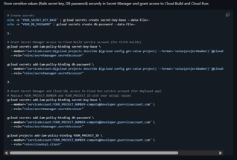 | Just separate out code more and add some more specific details to each line where necessary
“Deploy to Cloud Run” needs to be clarified so that the next team can more easily understand the code/instructions. | Low | 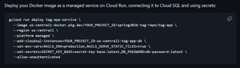 | Separate out the code lines and make sure the person reading the README can understand why they need to run those lines of code.

